SEDA Research and Evaluation Small Grants

Final report

Name and institution
Catherine McConnell, Senior Lecturer, Centre for Learning and Teaching, University of Brighton
Sharon Morley, Graduate Research Assistant, Centre for Learning and Teaching, University of Brighton

Project title
Student Collaborators in Educational Development

Background and aim of the study

Background
The current wealth of literature and practice-based examples of student engagement outline that involvement with the university community is considered to have a major impact on their success, from integration, persistence and achievement, to graduate skills and employability (Astin, 1999; Yorke and Longden, 2008; Jones, 2008). Whilst the practice of students in university-wide employment is becoming more commonplace, relatively little has been known across the sector about the practice of involving students in educational development and learning and teaching centres.

Aim
This study aimed to make initial investigations with colleagues across the sector, and add value to the relatively limited knowledge base about student involvement with educational development.

Research questions
- What is the provision for involving students in educational development departments across the UK higher education sector?
- What are the perceptions and experiences of staff and students involved in this partnership work within educational development settings?

Methodology

The study was conducted in two stages.
1. An online survey (Appendix 1) distributed to educational and learning development colleagues via two jisclists:

LDHEN@JISCMAIL.AC.UK – the Learning Developers in HE Network
SEDA@JISCMAIL.AC.UK – Staff and Educational Developers Association

The survey results were coded to allow for the development of interview questions (Appendix 2).

2. Following the survey, colleagues that had volunteered to participate in the interview stage of the study were contacted. Seven semi-structured interviews were conducted, recorded and transcribed.

Data analysis
We coded the transcribed interview data using a combination of a theoretical and inductive approach (Braun and Clarke, 2006). The initial stage of coding involved ‘first impression’ phrases being drawn from an open-ended process of initial coding (Saldana, 2009). A second cycle of coding led to reclassification of the data allowing clarification of categories and sub-codes. This led to the emergence of overarching latent themes and concepts examining not only what was said, but also underlying assumptions and conceptualisations.

Narrative accounts
A further online survey (Appendix 3) to ascertain the perceptions and experiences of students engaged in educational development was designed and distributed to those educational development colleagues that had responded to the initial survey. This was distributed to the students with whom they collaborate within their departments. There were 17 separate responses and these will be used to create a web resource illustrating ‘students’ stories’: http://blogs.brighton.ac.uk/studentcollaborators

Committee recommendations

The SEDA committee recommended that the original plan to create a website as outlined in the proposal should be altered and a web page created as an alternative. This recommendation has been observed and a project web page is in progress.
http://blogs.brighton.ac.uk/studentcollaborators

Findings

Staff survey
The survey distributed to educational development colleagues produced a wide range of responses from 30 institutions across the UK HE sector. The responses to two questions in particular have been displayed in word cloud format.
Q. What form do opportunities for student engagement in educational development take at your institution?

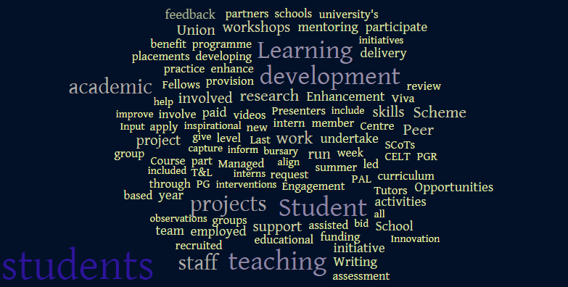

Q. What do you consider to be the barriers to student engagement in educational development?

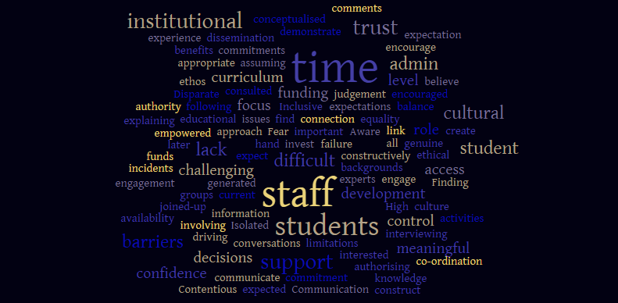

Follow up interviews
The analysis of the interview data from colleagues from 7 institutions across the UK led to the identification of several main themes. These are as follows:

Formality and informality of practice

The formality and informality of the practices identified by our participants can be considered to exist as a continuum, with the generally expressed opinion being that a section in the middle of this continuum allowed for the most effective staff-student collaboration.

The formality in these practices was considered to lie within the structures of the practice whereas the concept of informality was considered to exist within the interpersonal relationships of the partnership.

Qualities of partnership

Participants identified a need for staff to be engaged and empowered to step out of the expert role to work in partnership with students. It was also recognised that for a successful partnership students must be prepared to accept responsibility for their own learning.

A further point that emerged from this research were the qualities considered to be inherent in a good partner. These included effective communication, support and respect, commitment, consistency, creativity and a willingness to compromise.

Practical tensions and barriers

Time was identified as a barrier to engagement for both staff and students. Difficulties such as busy timetables, student placement and student willingness to give up free time were repeatedly referred to.

Resources were considered an issue by many participants with reference to external funding. Many participants expressed their perception that without external funding there would be limited opportunity for student engagement.

Disciplinary differences were referred to as a difficulty with some participants stating that disciplines with strong academic traditions are less likely to embrace student engagement. It was also noted that some academics consider their role to be solely teaching. One participant suggested however that these differences may be due to individual personalities rather than the discipline. It was generally agreed that it is difficult to ascertain a cause for disciplinary differences and although there was not the possibility to examine this phenomenon further in this study there is scope for further research into disciplinary differences in student engagement.

Student related issues were referred to by all participants but the findings were divergent. Student expectations were considered an issue, in that some students expect and are content to take a passive role in their education. Some participants also referred to students having an issue with the remedial image of learning development. For a large number of participants an important issue was the fact that students are not accessing the opportunities for engagement, in many cases by not reading emails or accessing advertisements on the student website.

Reflection

The learning that has taken place through this initially proposed ‘small-scale’ enquiry have far surpassed our initial aims and planned outcomes. The project itself has enacted a staff-student collaboration on a piece of research that has enriched both team members experience and learning through partnership working. The networks and contacts made through the survey dissemination and follow-up interviews have led us to new cross-institutional practice sharing, both among the educational development community, and those students involved in educational research and development. The findings and narratives that participants have contributed are honest and generous reflections on their own and institutional practices, and are valuable for the SEDA community to reflect upon.

Dissemination

In addition to the project web page http://blogs.brighton.ac.uk/studentcollaborators, two conference presentations have been made in order to tell others about student collaborators in educational development:

1. McConnell, C & Morley, S (2015) ‘Students as Collaborators in Educational Development’ paper presented to Enhancing Higher Education through Research conference, University of Brighton, 6 Feb 2015.
2. McConnell, C & Morley, S (2015) ‘Engaging Students in Research and Scholarship’ paper presented to the Inaugural European Conference on the Scholarship of Teaching & Learning: Bridging Boundaries through the Scholarship of Teaching & Learning, University of Cork, 7-9 Jun 2015.

Impact

This project has inspired new areas of research and collaboration, and has raised the profile in our own institution of the value and benefit of working in partnership with students towards enhancing learning, teaching and co-research. Raising awareness across the HE sector of the innovative approaches to student involvement in educational development has been achieved through the participation of over 30 colleagues from institutions across the UK. In order to share the project findings we plan to co-author a journal paper that can offer more depth, and a description of student partnership approaches that can be adopted by educational developers more broadly.

For more information please contact:
Catherine McConnell - C.McConnell@brighton.ac.uk

Appendix 1

Survey Questions

1. Does the institution in which you work provide opportunities for students to engage in educational development?: Y/N
2. If yes: Does the institution in which you work provide opportunities for students to engage in educational development?: (describe)
3. How are these opportunities presented to students and are there any limitations to involving students?: (describe)
4. In your opinion, how effective are these opportunities in increasing student engagement in educational development?: (rate 0-10 [10 being most effective])
5. What do you consider to be the barriers to engaging students in educational development?: (describe)

Consent
I agree to participate in this study and understand that my identity and that of the institution in which I am employed will remain anonymous at this stage of the research.:

I am willing to be contacted for a further interview or focus group. My contact details are as follows:

Thank you for participating in this survey. We value your contribution and if you have provided your contact details we will keep you updated with project outcomes and any related events.

Appendix 2

Example interview questions (these were semi-structured; open-ended; tailored depending on the participant’s responses on the survey)

Could you tell us a bit more about the [“writing mentors”] you mentioned in the survey?

Is that outside of the curriculum?

Would you say it’s a kind of vision for [institution] or is it embedded within strategy?

Do you evaluate the impact of any of this?

One of the areas that we’re looking into is around when students are working collaboratively either with educational development departments or discipline academics, collaboratively working together. Do you know of anything like that going on at [x]?

You mentioned the writing mentors. Do you train them and what does that involve?

It sounds like the visibility can help the culture change?

Does that involve you collaborating with other departments at the university to make that happen?

Do you think that the buy-in from academics in terms of both developing academic skills and also student engagement as in involvement, what do you think are the factors for academics in that respect?

Do you think that some academics are more confident to either develop their students’ academic skills or involve students?

Is there any reward and recognition for lecturers to involve students….engage students say in students as researchers or the peer learning side of things?

Can you identify any challenges about involving the students in your initiatives?
Appendix 3

Student Stories

Your contribution is greatly appreciated. Please complete all questions marked with an asterisk*. Please also answer a minimum of 3 additional questions. Thank you for your interest.

Name *
University *
Course of study *
How are you involved in educational development at your university? Is your role paid or voluntary? *
What skills have you developed as part of this involvement?
What insights has this experience given you? For example, in to university workings, structures, or about your own interests?
How might this experience relate to life beyond university?
How does your role or experience relate to or enhance your studies?
What unexpected outcomes have arisen from being involved?
Have there been any impacts, such as personal or professional?
What ideas has your experience given you?
Has it made you view university, or your lecturers in a different light?
We plan to use these narratives as part of our project webpage - therefore please could you tell us if you would prefer to be anonymised, or with permission identifiable by your first name? *
- I would like to remain anonymous
- I give permission for my first name to be used
Your university will be named unless permission is not granted either by you or the staff member we are in contact with. We will send the staff member the full unedited text of your submissions so that a representative from your university can confirm that we can use them. *
- I give permission for my university to be identified and my submission to be forwarded to a member of staff
- I do not give permission for my university to be identified
Please provide your email address in case we need to clarify any information that you have provided. *

