IS GROUPWORK WORKING?
Teacher intentions, student experiences and effective learning strategies within the Undergraduate BA (Hons) Childhood, Youth and Education Studies programme

FINAL REPORT
15th February 2016
This project was supported by the
Staff and Educational Development Association (SEDA)

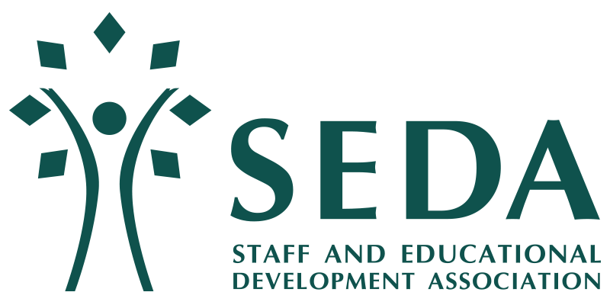

Project Team
Dr Alex Masardo, Department of Education, University of Bath A.Masardo@bath.ac.uk Tel: 01225 38 5306
Dr Kyoko Murakami, Department of Psychology, University of Copenhagen (formally Department of Education, University of Bath, until 30-Nov-14) kyoko.murakami@psy.ku.dk

Acknowledgements The project team are grateful for the input and assistance of a number of people to this study. In particular, we would like to thank the Staff and Educational Development Association (SEDA) for awarding the project team with small grants research and evaluation funding. A big thank you to all the students and staff members on the, then, BA (Hons) Childhood, Youth and Education Studies programme who took part in this study. Your input, insights and enthusiasm for the project have been invaluable. We would also like to thank Dr Skye Xin Zhao and Ms Samantha Stone for their research assistance. Finally, we would like to acknowledge the input of everyone who assisted in the linked Groupwork Matters workshop which resulted from the SEDA-funded project: Professor Peter Lambert, then Associate Dean for Learning and Teaching, Dr Mary Hayden, Head of Department of Education, Emma Powell and Dylan John (our first year undergraduates) for their help in making sure the Workshop ran smoothly, and Professor Ian Butler, for giving such a warm welcome to the workshop participants.

Contents Page
Introduction 4
The Findings 4
The Students 4
Staff issues 5
Table 1: Linking pedagogical approach and learning outcomes 5
Project Impact 5
Written reports and publications 5
Oral presentations 6
Linked funding – HSS Faculty Teaching Development Fund (TDF) 6
Audio-Visual Material 7
Research Funding 7
Teaching Practice 7
Developing Student Capacity 7
Concluding remarks 8
References 9
Appendix A – ‘Group Work Matters!’ Programme of Events 10
Appendix B – ‘Group Work Matters!’ Flyer 11
Appendix C – Department of Education WIWO Abstract 12
Appendix D – Project Costings 13

Is Group Work Working?
Introduction Within the Department of Education and the Faculty of Humanities and Social Sciences (HSS), group working as a learning strategy within undergraduate (UG) programmes has increasingly become a formalised part of the assessment process. While the rationale for such an approach is now well rehearsed within the pedagogic literature (HEA, 2015), the latent tensions and challenges it raises for both students and academic/teaching staff are less clear cut, not least due to the variety of contexts in which such learning takes place.
With support from the Staff and Educational Development Association (SEDA), the project team undertook a small scale exploratory study in order to examine current groupwork practice on the undergraduate programme on which they then both taught and were acting unit convenors – BA (Hons) Childhood, Youth and Education Studies programme (now Education with Psychology).
The project’s aims were three-fold:
- to understand the experiences of group working among first, second and final year UG student cohorts following the Childhood, Youth and Education Studies (CYE) programme;
- to establish whether these student experiences aligned with teacher expectations and anticipated learning outcomes; and
- to identify what worked well, what did not and where room may exist for improvement.
Using qualitative methodology, focus groups were conducted with a total of 23 students, recruited from a sampling pool of around 80 first, second and final year CYE students. In addition, all members of staff that were involved in teaching on the CYE programme from the Department of Education (n=7) and the Department of Psychology (n=3) were also invited to take part in a separate focus group, which resulted in a total of five staff participants.

Findings
The students
A number of key emergent themes and issues that arose for students were identified during the student focus groups. The key categories included below are being used as the basis of an executive summary and a journal article to be submitted by the project team to a teaching and learning journal (see outputs):
Division of labour/roles/contribution; Marking and evaluation criteria ; Assessment and learning outcomes; Students’ feelings towards group work; Who to work with ; Choice in group work allocation; Group work space, view share, media used and timing; Student strategies in group work; Links to future employment; Group size and class layout; Skills development.

Staff Issues
A number of key emergent themes and issues that arose for staff were identified during the CYE staff focus group. The key categories are included in Figure 1 (below) and are being used as the basis of the analysis of staff narratives that will feed into the executive summary and complement the journal article being submitted by the project team to a teaching and learning journal (see outputs).

Table 1: Linking pedagogical approach and learning outcomes

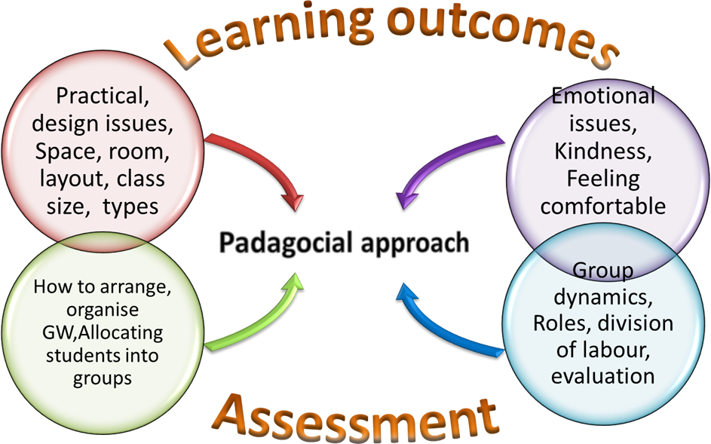

Project Impact
The outcomes of the SEDA project include the following:
Written reports and publications A summary report of the SEDA-funded project to be made available on the SEDA Grant-holders page of their website in 2016. An executive summary of the results of the project are currently being written up for the Director of Studies of the BA (Hons) Education with Psychology programme and will be made available on the University of Bath website in 2016. The results also form the basis of a journal article currently in preparation and due to be submitted to a leading educational research journal (TBC) later in 2016 by the project team.
Oral presentations Findings have been presented at the following events:
- Department of Education WIWO Seminar, 12 November 2014 (Appendix C)
- Groupwork Matters Workshop, University of Bath, 28 April 2015 (Appendix B)
- Exchange! 2015. Sharing Ideas for Learning and Teaching at Bath, 7 May 2015
Forthcoming presentations based on this work include:
- Results of the study will be fed-back to students and staff at programme-level in September 2016 at the start of the academic year 2016-17, thereby informing and enhancing the Education with Psychology teaching and learning experience.
- Attendance at a high profile Learning and Teaching Conference in 2017, e.g. SEDA, HEA or similar.
Linked funding – HSS Faculty Teaching Development Fund (TDF)
Additional funding of £500 was sought by the project team through the Faculty of Humanities and Social Sciences TDF in order to cover the costs of a Faculty-sponsored but University-wide Workshop in order to:
- disseminate the results of the SEDA-funded research;
- provide a platform for staff and student representatives across the University to share the results of their own experience, practice and research;
- provide an opportunity for staff and students from across the University to come together and share their ideas and experiences of teaching and being taught on degree programmes where group work forms part of the summative and/or formative assessment process.
In this way, the proposed event met the principal objective of the Faculty TDF – “to enable staff to develop, enhance and share teaching and learning practices to support the Faculty’s aim to continue to deliver a high quality student learning experience, as detailed in the University’s Education Excellence Strategy” (University of Bath, 2015). For details, see Appendix B
Groupwork Matters Workshop – April 2015
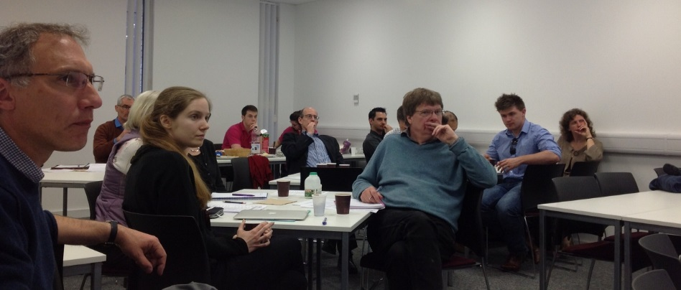
The Workshop took place on the morning of 28 April 2015.
It was attended by 24 delegates from across the university and included a range of stakeholders, including university tutors, researchers, undergraduate and postgraduate students, student representatives and support services.
The Programme of the meeting can be found in Appendix A.
The workshop was open to all staff and student members of all faculties across the university, to generate an open forum for discussion around group work and related assessment in the academic environment. The event was opened by the Dean of Faculty of Humanities and Social Sciences, Professor Ian Butler.
Participants heard from: the project team, Masardo and Murakami with Dr Skye Xin Zhao; the Student Union Education Officer, Paul Goodstadt; Dr Christine Edmead from the Learning and Teaching Enhancement Office; Dr David Skidmore from the Department of Education; and Dr Steve Cayzer from the Department of Mechanical Engineering. This was followed by a Question and Answer Panel Discussion in order to examine and debate the wider implications of the material presented and the discussions that had been generated.
The event closed with an exchange of ideas about next steps in the development of strategies for promoting successful group work both in the CYE programme and across the University more widely.
Audio-Visual material. Film, video and podcasts Consent was sought from speakers and participants for the event to be video recorded. The film rushes are currently being reviewed by Masardo and, following editing (including assistance from the university of Bath Learning and Teaching Enhancement Office), a short film that will include excerpts from the event will be made available as a resource for staff and students.
The project team have received an invitation from Mike Groves of the newly formed Academic Skills Centre (ASC) at the University of Bath to develop a Groupwork podcast for the ASC, as part of a broader series of short podcasts and videos to highlight to students the skills they need to prosper in an academic environment. This will include an interview with Masardo who will discuss insights gained from the research findings and workshop.
Research Funding The groupwork project and workshop have acted as springboards from which to inform further research. It is anticipated that funding will be sought through RCUK to carry out a series of group-work interventions, tied to promoting student collaborations through group work based on practice-centred models of intervention currently being taught by Masardo to undergraduate Education with Psychology students on the unit ED20437 Interventions, Organisations and Practice.
Teaching Practice Drawing on findings from the SEDA- and Faculty TDF projects, teaching provision was provided by Masardo to new members of staff on probation at the University of Bath undertaking Section A of The Bath Course in Enhancing Academic Practice, 23 February 2015. Theme: Groupwork and best practice. Convenor, Dr Rachael Carkett.
Developing Student Capacity In accordance with the University of Bath (2016) University-Student Partnership Statement, the project team sought to provide opportunities for both undergraduate and postgraduate students in the Faculty to become involved in the development of both the SEDA and Faculty TDF projects. To this end, funding was earmarked for a Research Assistant (Xin Zhao, former PhD student in the Department of Education; now Dr Zhao), focus group transcriber (Samantha Stone, former CYE student currently undertaking a MRes in Education); Workshop organisers (Emma Powell and Dylan John, then first year Childhood, Youth and Education Studies students). This partnership approach to developing student capacity is a process that the project team strongly support in all aspects of their teaching and research practice.
Concluding remarks The dual strands of this project are intended to raise both student and staff members’ awareness of the importance of group work, its academic relevance and how its effective use can form part of the skill set necessary for augmenting student employability. Both academic skills and employability have been flagged up as two of four ‘key focuses’ for supporting first year student transition (University of Bath, 2013). The outputs from the linked SEDA- and FTDF-funded projects outlined in this report will help to develop our tutors’ capacity to improve and embed group work successfully in their unit teaching as well as seeking ways in which it can be assessed fairly, reflecting the achievement, competence and effort of the individual. Indeed, ‘develop[ing] policies on fairer group work marking’ has been highlighted as one of a set of ten priority objectives for 2013-14 by the Student Union (BathStudent.com/TopTen, 2013).
Established in 2009, the CYE programme is delivered by the Department of Education with input from the Department of Psychology. The CYE and subsequent Education with Psychology student cohorts to date have been unusual across the university in terms of their size (<40), gender (predominantly female) and ethnic homogeneity (predominantly white British) and the need arises to understand our own pedagogic approach to implementing group work in the unit teaching.
Research on group work over the past 15 years has had an almost exclusive focus on ‘finding common ground’ (Arkoudis et al., 2010) among domestic, international and ethnically diverse student populations (HEA, 2013). As a result, our understanding of how new insights gained from such work might impact or translate to more homogenous group settings has been under considered.
In this way, the focus group work is adding to current knowledge in this field. Moreover, beyond what has already been identified in previous research on group work in higher education at undergraduate level, the research has enabled the project team to identify 'hidden' barriers for students that pertain to assessment, relational issues reflected in the group dynamics such as friendship networks outwith the lecture room, and ‘unfamiliarity’ and ‘unease’ with group work processes.
In terms of assessment, the project team intend to highlight in their executive report and journal article the perceptions of and tensions between effort (work put into the group work) and the actual reward (mark) individual students receive. We have explored reasons as to how group work improves or hinders the students' learning and how learning is linked to assessment and other aspects such as curriculum and learning policy (Quality Assurance codes) in the higher education environment. In addition, the research has uncovered unspoken dilemmas and challenges experienced by tutors in the planning, implementation and assessment of students' group work.
References
BathStudent.com/TopTen (2013), 2013-14 Top Ten: Working for Issues That Affect You, University of Bath Students’ Union. Available at: http://www.bathstudent.com/your-union/topten/ [accessed on 20.11.13]
Higher Education Academy (2015), Group Work. Available at: http://www.heacademy.ac.uk/resources/detail/internationalisation/ISL_Group_Work [accessed on 05.02.16]
University of Bath (2013), Enhancing the undergraduate first year student experience: supporting student transition into higher education. Available at: http://www.bath.ac.uk/studentservices/fyse/map.pdf [accessed on 20.11.13]
University of Bath (2016) University-Student Partnership Statement. Available at: https://www.bathstudent.com/assets/site_resources/University-Student%20Partnership%20Statement%20final-1.pdf [accessed on 05.02.16]

Appendix A
Faculty Teaching Development Fund
Department of Education

Group Work Matters!
Tuesday 28th April 2015, Time: 9:15-12:10, Room: 1West 2.104

Programme
9:00 | Coffee/Tea, Biscuits and Registration
9:15 | Welcome  Professor Ian Butler, Dean of the Faculty of Humanities & Social Sciences
9:20 | Introduction  Dr Alex Masardo and Dr Kyoko Murakami
9:30 | Group work - A reoccurring theme for students  Paul Goodstadt (Student Union Education Officer)
9:40 | Supporting group work across the University  Dr Christine Edmead (Learning & Teaching Enhancement Office)
9:50 | Results of the SEDA-funded study:  Is group work working? Teacher intentions, student experiences and effective learning strategies within the UG Childhood, Youth & Education Studies programme  Dr Alex Masardo/Dr Kyoko Murakami/Dr Skye-Xin Zhao
10:20 | Break (Refreshment)
10:40 | A change of mind: how dialogue in groups enhances student learning.  Dr David Skidmore (Education)
11:05 | Creating and supporting effective teamwork in Engineering Design  Dr Steve Cayzer (Mechanical Engineering)
11:30 | Question and Answer Panel Discussion
12:00 | Next Steps
12:10 | Close
Appendix B

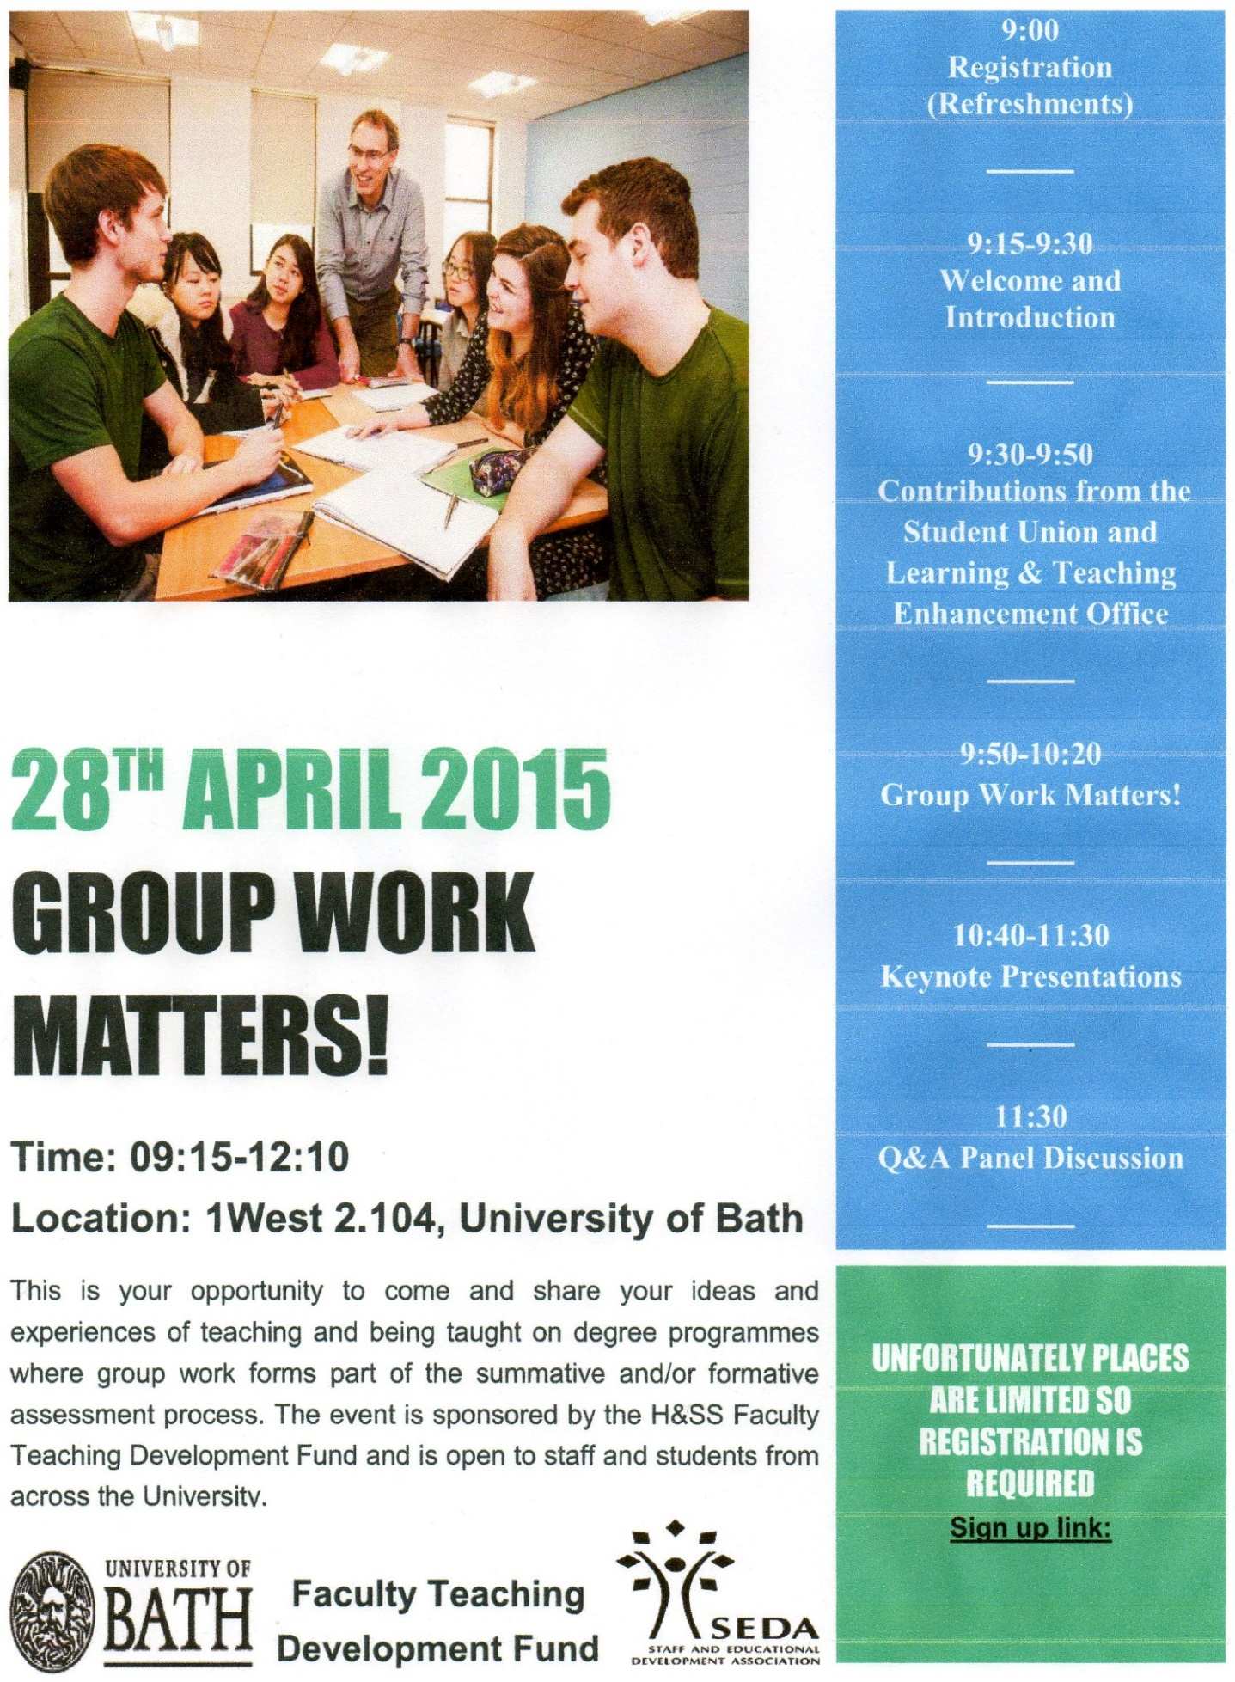
Appendix C
Department of Education WIWO Abstract
Departmental WIWO Seminar, Wednesday 12 November 2014. Room 3.8

“Groupwork! I just wasn’t expecting it to play such a large part in Higher Education assessment”

In this WIWO, I will report on two projects I am currently working on:
(i) Changing patterns in vocational entry qualifications: student support and outcomes in undergraduate degree programmes. Mixed-methods, HEA Funded, with Dr Robin Shields, School of Management;
(ii) Is group work working? Teacher intentions, student experiences and effective learning strategies within the undergraduate Childhood, Youth and Education Studies programme. SEDA and Faculty Teaching Development-funded, with Dr Kyoko Murakami, Department of Education.
In particular, I will take this opportunity to speak to a key theme that has begun to emerge in early analysis of the qualitative data across both projects; namely, the surprise with which assessed group work is received by undergraduate students arriving with a range of entry level qualifications. I will reflect on some of the potential implications for the way students are being prepared for Higher Education.

Dr Alex Masardo, FHEA

Appendix D
Project Costings
Table 1
List of Expenditures | Cost (£)
Catering and refreshments (including cold finger buffet and drinks)  Research Assistant costs (including transcription, assisting with coding and data analysis) | 250  750
TOTAL | 1000

